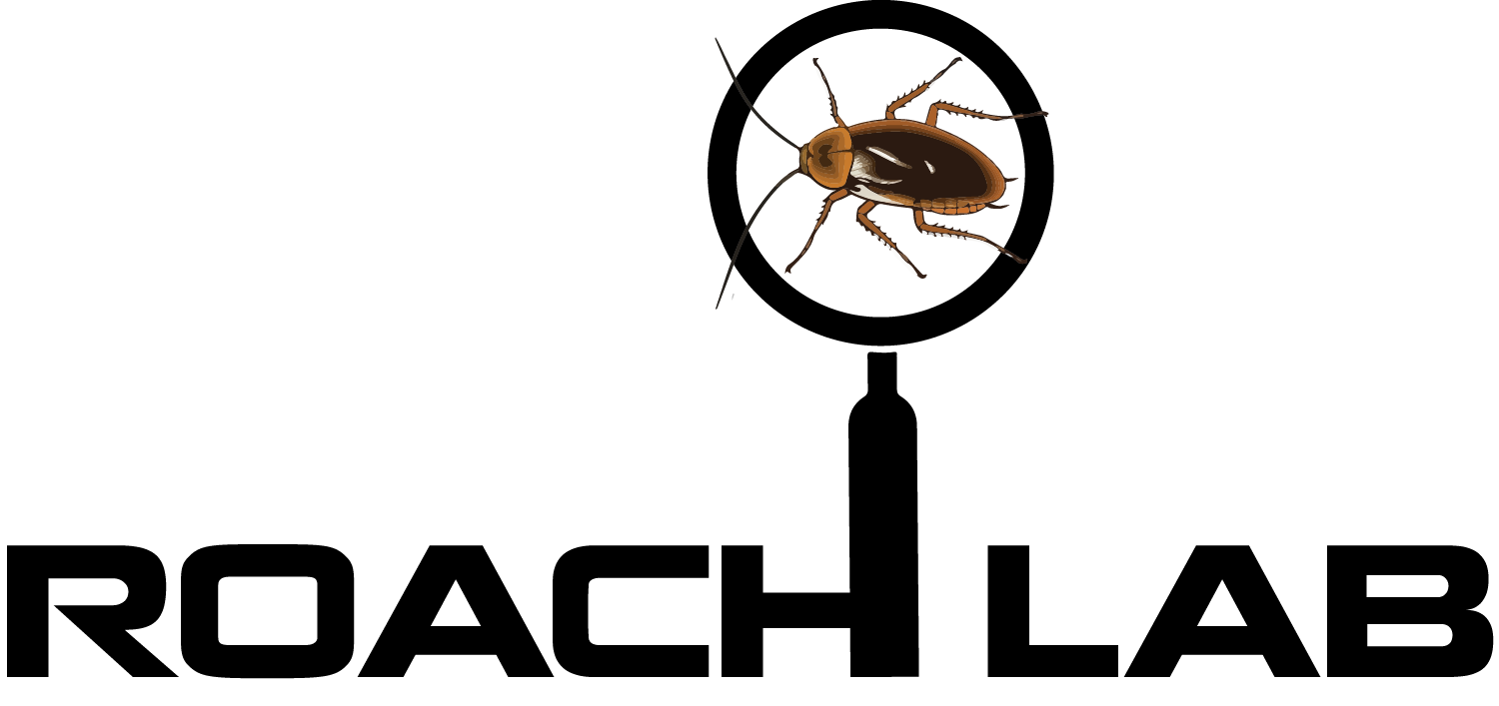

Cockroach Preference Test

Prepared by Kara Watts and Darby Proctor

This experiment can be used to determine whether or not a cockroach has a preference when given two options. It is currently designed to test between Frootloops and cricket diet. However, this experiment can be adjusted to test any two items including; various edible items, colors, smells, shelters, etc. This experiment can be used to test the preference of a single cockroach or test whether species wide preferences exist using several cockroaches.

Materials Needed

- Frootloops (available at most grocery stores)
- Cricket Diet (available at most pet stores, often in the reptile section)
- Timer
- Petroleum Jelly
- Cotton Swabs (or something similar to use as a probe)
- Cockroach Preference Testing Arena (see instructions on page 3)
  - Including feeding drawers, bottle caps, and divider.
- Data Collection Sheet (see page 5)

Part 1: Setting up the Arena
- Coat the inner walls of the testing arena with the petroleum jelly. This will make it difficult for the cockroach to climb over the walls.
- Position the feeding drawers under each choice chamber.
- Fill two bottle caps with crushed Frootloops and the remaining two with cricket diet.
- Place the bottle caps in the feeding drawers in the order determined by the data collection sheet. For example, on the first trial, Frootloops will be on the left. For the second trial, Frootloops will be on the right. Each half of the arena is where one trial will take place. Before beginning the experiment, load both the left and right sides of the arena, so that you are prepared for both trials 1 and 2.
- Place the divider in the middle of the testing arena to create two separate test areas.

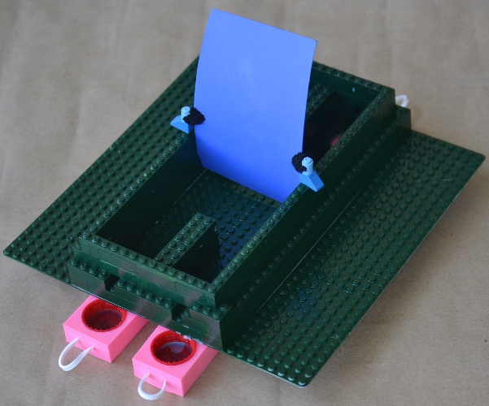
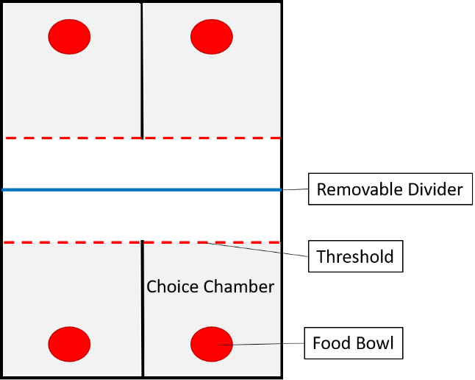

Part 2: Running the Experiment
- Place the cockroach in the left side of the testing arena, facing the choice chambers, and start a 10-minute timer.
  - If it attempts to climb out of the arena use the cotton swab to gently push it back into the arena.
- Start a 10-second timer as soon as the cockroach starts eating from one of the bowls. If the cockroach remains in the choice chamber, without crossing the threshold back into the arena, then record that food item as the cockroaches’ choice. That will be the end of one trial.
  - If the cockroach leaves the choice chamber before the end of 10 seconds, allow the cockroach to continue to explore and repeat Step 2 until either a choice is made or three minutes elapse.
  - If three minutes elapse without the cockroach making a choice, gently slide the divider toward the cockroach until it enters one of the choice chambers and record it as a forced choice.
- Once a choice (or forced choice) is made, remove the food from the chamber by sliding the drawer until the food bowl is no longer visible within the chamber.
  - Be careful not to pull the drawer too far as to open a space in the floor for the cockroach to escape.
- Raise the divider so that the cockroach can access the second set of choice chambers. Once the cockroach leaves the choice chamber replace the divider behind the cockroach so that it cannot access the first set of choice chambers.
  - If the cockroach does not leave the choice chamber use the cotton swab to gently probe it across the threshold.
- While the cockroach approaches the second set of choices on the right side, reset the drawers on the left side sliding the feeding drawers so that the food bowls are visible. Use the data collection sheet to determine which chamber each food option should be in.
- Continue steps 1 – 5 until 10 minutes elapse.
- If you are testing multiple roaches, be sure to clean the testing arena between each individual. Roaches can leave chemical trails behind that may influence subsequent individuals.
Data Analysis

Calculate a preference score for each choice option by dividing the number of times the option was selected by the total number of choices (and forced choices) made. A larger preference score means the cockroaches shows a higher preference for that option.

Example:
$$Frootloop Preference Score= \frac{\# of Frootloop Choices}{Total \# of Choices+Total \# of Forced Choices}$$

Cockroach Preference Testing Arena Construction

We have found that Legos are a great material for using with the roaches because of how customizable they are. Below are our plans for the Lego testing arena. Feel free to use an alternative arena, as needed.

Materials Needed
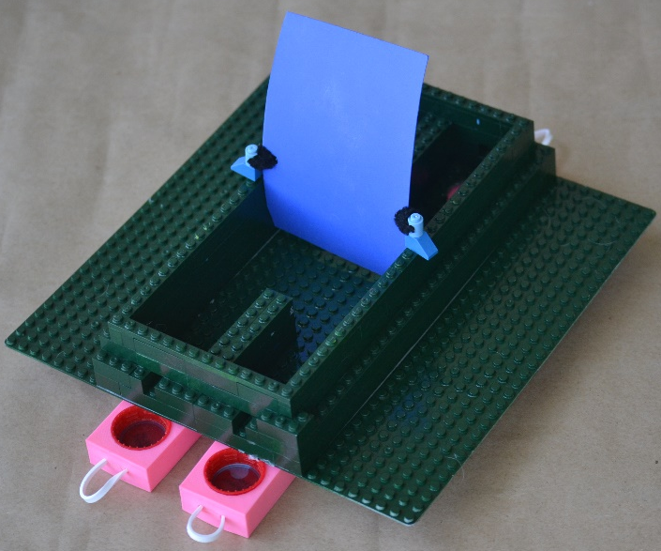
- Legos (or generic building bricks)
  - Baseplate min 32 bricks x 20 bricks
  - 1x10 Bricks x12
  - 1x8 Bricks x8
  - 1x6 Bricks x22
  - 1x3 Bricks x4
  - 2x8 Bricks x2
  - 2x4 Bricks x6
  - 2x3 Bricks x6
  - 2x2 Bricks x18
  - 1x1 Brick with hole x2
- Rubber band or twine
- 4 Soda Bottle Caps
- 90 x 70 mm Sheet of sturdy plastic
  - Reused plastic cut from used notebook covers works well for this.
- Flexible wire
The bricks listed in materials provide an example of what bricks can be used to complete the testing arena dimensions. However, any combination of bricks can be used so long as the dimensions remain 30 bricks long by 14 bricks wide by 4 bricks high or 220x90x40 mm, with the choice chambers being 7 bricks long by 5 bricks wide or 63x40 mm. A 1x1 brick space will remain open in the wall of each choice chamber. Finish Lego arena by drilling a 20 mm hole centered at the end of each choice chamber. See image for suggested construction.
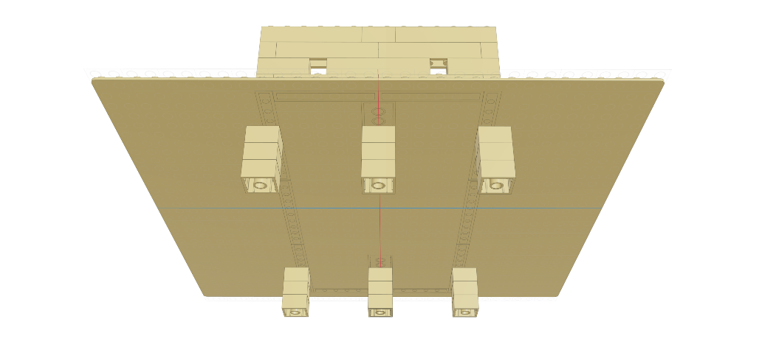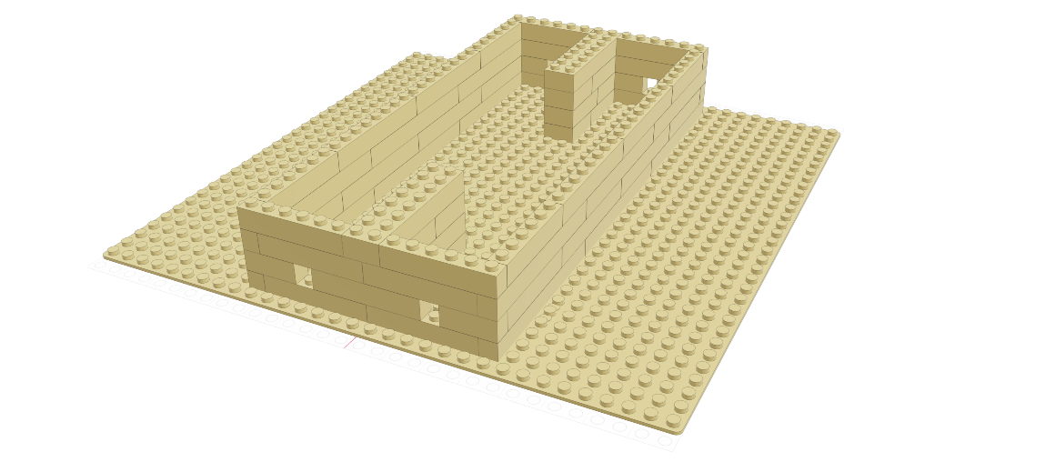
Note: Paint the arena a solid color if multiple colored bricks are used. This would prevent any color bias should any exist. However, you could also use colored bricks in certain areas if you are interested in exploring color preferences or if you want to use this arena to test other concepts such as using landmarks.

Once the arena is built you will also need to construct the divider and four feeding drawers.
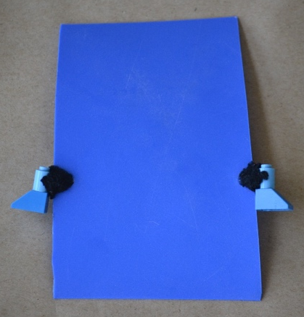
To make the divider simply cut a sturdy sheet of plastic (we used the front cover of a used notebook) to 70x90 mm. Cut one hole on each edge of the sheet 50 mm from the bottom. Attach one of the 1x1 bricks with a hole to one of the holes on the side of the sheet using the wire. The brick should be held up by the wire off to the side of the sheet. Repeat on the other side. The divider should have one brick on each side of it so that it can be placed upright in the arena attaching along the walls. Ensure that there are no gaps underneath or to the either side of the divider that would allow cockroaches to get through.

The feeding drawers must be 3D printed. Once printed, handles can be added to the drawers by treading rubber bands, or twine, through the holes on the end. Each drawer should be printed to hold a soda bottle cap which will act as a food bowl for testing. For a variation on this test, you may also compare food to shelter preferences. The Lego arena is sized to fit this shelter that can also be 3D printed.
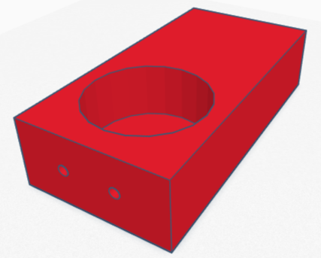

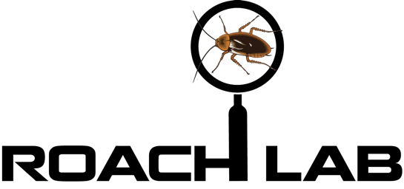

Preference Test Data Collection Sheet

Cockroach ID:
Date:
Option 1: |  | Option 2:
Left Drawer | Right Drawer | Choice
1 | 2
2 | 1
2 | 1
2 | 1
1 | 2
2 | 1
2 | 1
2 | 1
1 | 2
1 | 2
2 | 1
2 | 1
1 | 2
1 | 2
1 | 2
2 | 1
1 | 2
1 | 2
2 | 1
1 | 2

Note: Assign each choice option to either 1 or 2; example: Frootloops = 1; Cricket Diet = 2. Record each choice, including forced choices, under the “Choice” column.

