Cockroach Husbandry Guidelines

Cockroaches live in nearly every environment on the planet and can survive with minimal resources. However, as psychologists, we are also required to consider their psychological well-being, no matter how minimal their needs may be. Therefore, our guidelines go beyond many guidelines for caring for roaches that you may find on the internet. Furthermore, our husbandry guidelines are specifically for discoid roaches, Blaberus discoidialis.

Why Blaberus discoidialis?

Discoid roaches are big, slow and can’t fly. This means they are easier to handle than the typical roach you might find in your house. They also look a bit different than the roaches we commonly see in America. Their looks and lack of flying ability tend to make people more comfortable around them.

Discoid roaches are from the Caribbean and thrive in very warm climates. In the continental US, discoid roaches would not survive winter if they escaped their habitat (but don’t worry, they won’t!). This is an advantage because some states, like Florida, are very concerned about potentially invasive species. Most species of roaches are illegal to import to Florida because of this possibility. One exception is the discoid because they can’t survive even the mild Florida winter. So, this species should be legal in the continental US, but do check your local laws before ordering the roaches.

Getting Discoid Roaches

You can buy discoid roaches from various suppliers on the internet. They are sold as feeder insects for reptiles, so are fairly inexpensive. You will need to plan ahead though, as they can’t be shipped in the winter, because it is too cold. We use Joe’s Bugz, but again, they are available from a variety of vendors.

Housing

Containers:

We suggest housing your roaches in clear plastic or glass terrariums with a mesh lid. Discoid roaches can’t fly and are not very good at climbing slick surfaces. Regardless, we think it is a good idea to keep your terrariums covered. Fish tanks with mesh lids are also a good option.

We house our roaches socially, with about 25 roaches per 10-gallon terrarium. We have not been able to find many guidelines on the maximum number of roaches that should be housed together, so this is an area you could explore. If you figure something out, let us know! We do think this species is territorial based on some behaviors we have seen in the lab, so it is probably best not to overcrowd them.

Housing them in clear containers also means that you can watch your roaches. While this may not sound too exciting, there is more social behavior than you might suspect. Your colony could also be used for behavioral observations, if that is something you are interested in.

Substrate:

Discoid roaches like to bury themselves. So, they need a substrate that will accommodate that behavior. This can be as simple as some dirt that you collect from outside. We, however, like to use substrate from pet stores, as this has fewer other critters in it than the soil where we are located. One example is Zoo Med Eco Earth Loose Fiber Substrate, but others would work as well. The important thing is for the roaches to be able to dig into it. We place about an inch of substrate at the bottom of the terrarium. If you don’t see your roaches, look for their antennae sticking up from the soil.

We have also recently been trying out using pine bedding that you would use for rodents. The pine bedding is nice because it is easier to spot the roaches, as they tend to blend in with soil. This is convenient when you are replacing the substrate, which we do about once a month. This is particularly nice if you are going to breed your own roaches, because the infants can be quite hard to sift from soil.

Shelter:

As you may know from your own experiences with roaches, they like to hide. So, it is important to give them places to hide. This can be as simple as toilet paper tubes. However, we recommend giving them hiding places that make the roaches appear more approachable. In other words, we give our roaches a hamster house because it makes them seem less gross to people who are hesitant about being around roaches. Browse your local pet store for whatever housing works for your terrarium.

Enrichment:

Do cockroaches need enrichment? We don’t know. But, as psychologists, we need to consider their psychological needs, no matter house small they may be. Therefore, we also include other climbing structures for our roaches. The hamster section of your local pet store will have several options. In some of our habitats we also include a 3D printed roach wheel that was designed by Backyard Brains. Unfortunately, they have stopped selling this, but if you contact them they have some left. It is on our list of things to do to design and post plans for a similar wheel. And yes, the roaches do use them. Whether or not the roaches know they are using them is a different question. See below for an example of one of our roach habitats.

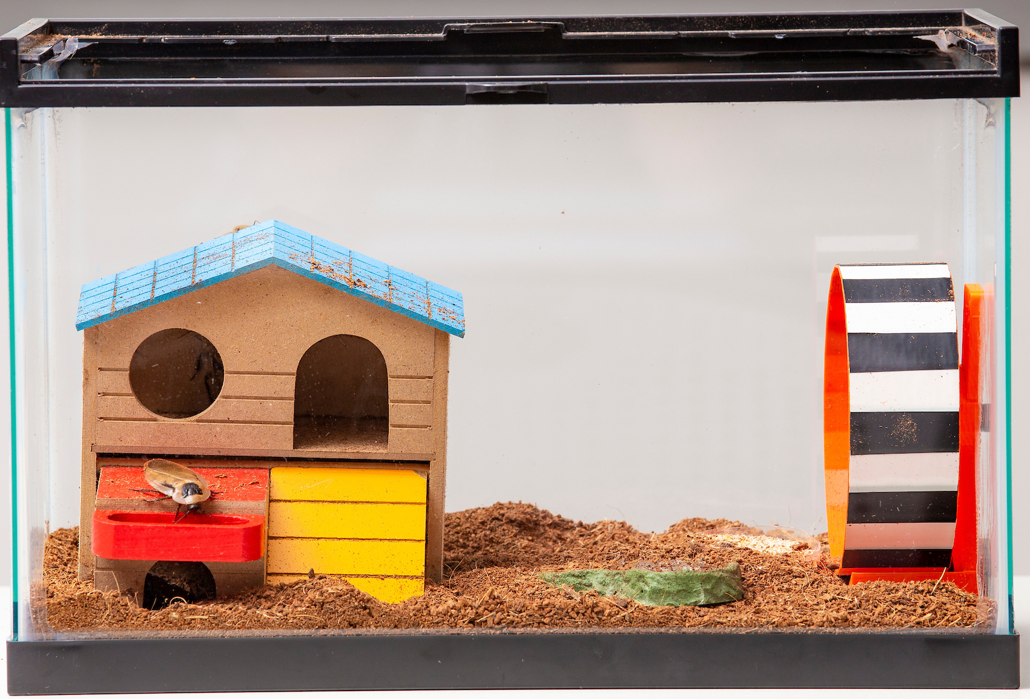
Food and Water

Roaches will eat just about anything, so you could give them a diet of whatever you have sitting around. However, as we anticipate your roaches are likely to be stored in an office or classroom rather than a dedicated lab space, we have a few recommendations for food that will not mold nor smell. Roaches don’t eat much, so these options will last for quite a while. We give our roaches a small bowl full of this food once a week.

Food options:

- Nature Zone Bites for Roaches (available at our local Petco, but not other pet stores)
- Fluker’s High-Calcium Cricket Diet (available at most pet stores, often in the reptile section)
- Fluker’s Orange Cube Complete Cricket diet (available at most pet stores, often in the reptile section). Note: This diet does have a bit of an orange smell, so it is not our preferred diet. That being said, the roaches really like it and will often come running when you give them fresh food.

Water:

Our roaches seem more thirsty than hungry, so a constant supply of fresh water is a must. However, the roaches often track their substrate into the water, so a bowl of water is not the best option. Instead, we use water polymer crystals. You can easily find these on the internet. A bag will last a very long time (years maybe!).

Follow the instructions on your bag for hydrating the crystals. You basically add a small amount to a container of water and the crystals will absorb the water. You can then give the roaches a bowl of the hydrated water crystals. This stays much cleaner than a bowl of water.

The roaches will need fresh water crystals every two to three days. You will be able to tell when the crystals start drying out. When you give them fresh water, watch for a few minutes as they will often congregate at the water bowl!

Reproduction

Want to have your own self-sustaining colony of roaches? It is easy, just house males and females together and about a month later you will have babies! However, this strategy will end up with you having more roaches than you probably need. Therefore, it is best to separate your roaches into male and female habitats.

You can only sex discoid roaches once they become adult. They are adults after their last molt and they emerge from that molt with wing. Until then, they do not have wings. As soon as you see adults, you need to separate them. Roach Crossing’s husbandry guide has a nice picture of how to sex your roaches on page 5.

Discoid roaches will reproduce slower at cooler temperatures and more rapidly at warmer temperatures. When housed in a temperature controlled building, they can have babies about once a month. The babies then take about six months to become adults and will then live for another year to year and a half.

