Cockroach Probability-Learning Test

Prepared by Kara Watts and Darby Proctor

This experiment is used to determine whether cockroaches are capable of probability matching, which entails that their choice-ratio would eventually match their reward-ratio. This experiment is loosely based on the following article:
Longo, N. (1964). Probability-learning and habit-reversal in the cockroach. The American Journal of Psychology, 77(1), 29-41. doi:10.2307/1419269

Materials Needed

- Sucrose-rich treat (sucrose solution, Frootloops, etc.)
- Timer
- Petroleum Jelly or clear plastic sheet (available at most home improvement stores, but are more expensive than Petroleum Jelly)
- Cotton Swabs (or something similar to use as a probe)
- Lego Y-Maze (see page 4)
- Data Collection Sheet (see page 6)
- 3D Printed Roach Shelter (Follow Link)
Part 1: Setting up the Apparatus
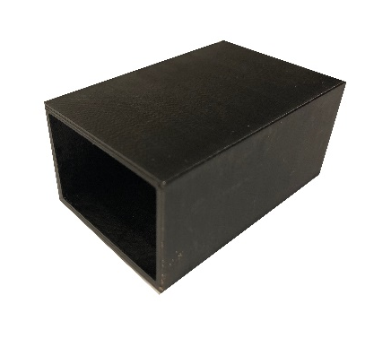
- Coat the inner walls of the Y-maze with the petroleum jelly. This will make it difficult for the cockroach to climb over the walls.
  - Alternatively, you can use a plexiglass sheet to cover the maze to keep the cockroaches from climbing out.
- Position the shelters at the end of each side of the Y-maze with the goal shelter open face out, so that the roaches may enter the shelter, and the dummy shelter closed face out, so that the roaches cannot access the shelter.
3D Printed Shelter
- Place a treat inside of the goal shelter.
- Place the divider in the middle of the testing arena to create two separate test areas.

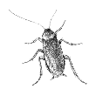
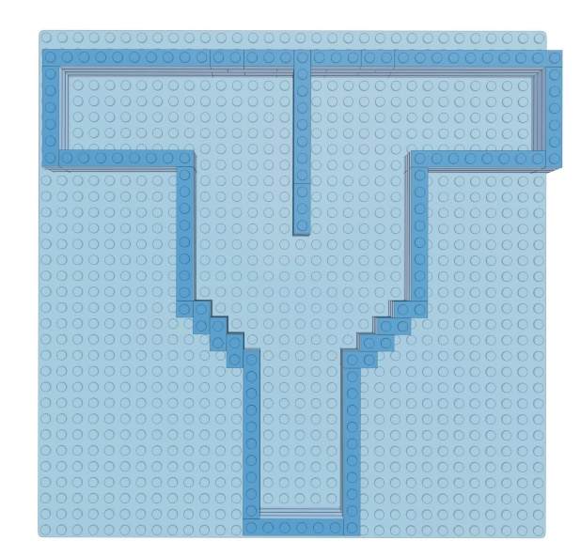
Start
Dummy Shelter
Goal Shelter

Part 2: Running the Experiment
- Randomly assign half of the cockroaches to a 100:0 group and half to a 70:30 group.
- Randomly assign half of each group to either left or right.
  - Half of the 100:0 group will have the right side be correct 100% of the time, while the other half left is correct 100% of the time.
  - Half of the 70:30 group the right side is correct 70% of the time, while the other half left is correct 70% of the time.
  - You can also explore other ratios. Keep in mind that the larger the ratio difference, the better animals tend to be able to discriminate between the options.
- Place the shelters according to the ratio groups.
  - Ensure that the ratio distribution includes the minority at least once every 5 trials (Example schedule page 5). In other words, do not have five trials in a row where the correct option is on one side. This could inadvertently cause a side bias.
- Place the cockroach at the starting point of the Y-maze, facing the maze, and start a timer.
  - If it attempts to climb out of the maze use the cotton swab to gently push it back into the arena. Alternatively, cover the arena with a clear plastic sheet.
- Record the side selection when the cockroach either enters the goal shelter or reaches the dummy shelter.
- Repeat steps 3 – 5, 10 times per cockroach per day* until all cockroaches have achieved stable performance. Record number of days and trials until stability achieved.
  - Be sure to clean the testing arena between each individuals. Roaches can leave chemical trails behind that may influence subsequent individuals. One way to get around this is to place the maze on a sheet of paper, rather than a Lego plate. This way you can switch out the paper after each roach.
- Switch the probability for each group and replicate steps 3 – 6.
  - 100:0 group switches to 0:100, 70:30 switched to 30:70 and vice versa.
- Randomly reassign each cockroach into either a 40:60 group or a 20:80 group and repeat steps 3 – 6.
- Shift all groups to a 50:50 probability ratio and repeat steps 3 – 6.
* Sometimes the roaches are not overly motivated to participate in trials. So, you may consider reducing the number of trials per day. Alternatively, we have found that female roaches tend to explore experimental arenas more than males, so you may want to consider using only females. However, you could also use sex as an additional variable.

Data Analysis

Find the mean and standard deviation for each side selection from each probability group once stability is achieved. Each group should demonstrate probability matching by having a side selection mean approximately equal to the probability ratio (within 10% error). For example, the 70:30 group should be selecting the majority side approximately 70% of the time. Plot the data from each day in a line graph to see the performance progression of each probability ratio, as well as in the transition between ratio groups.

Extension

Once stable performance has been reached, you could extend the experiment by including a reversal condition. For example, if a roach had the reward on the left 70% of the time, in the reversal condition the reward would be on the right 70% of the time. You can then analyze how long it takes the roaches to learn to reverse their preference.

Cockroach Y-maze Construction

We have found that Legos (or generic building bricks) are a great material for using with the roaches because of how customizable they are. Below are our plans for the Lego testing arena. Feel free to use an alternative arena, as needed.

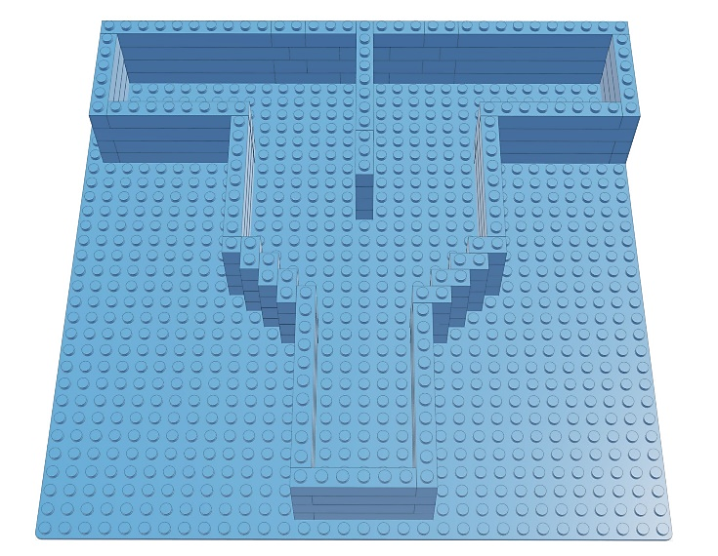
Materials Needed
- Legos (or generic building bricks)
  - Baseplate min 32 bricks x 20 bricks
  - 1x10 Bricks x19
  - 1x8 Bricks x14
  - 1x6 Bricks x12
  - 1x4 Bricks x2
  - 1x3 Bricks x10
  - 1x2 Bricks x29
  - 1x1 Bricks x 3

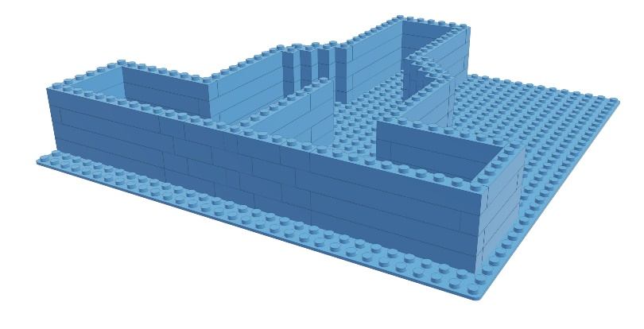
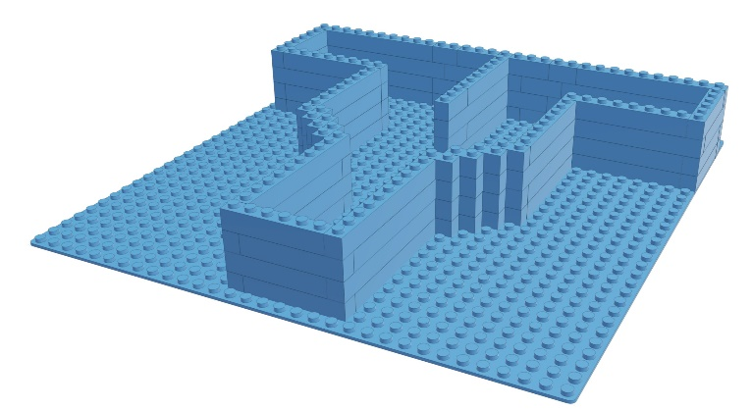

The bricks listed in materials provide an example of what bricks can be used to complete the Y-maze. The ends of the maze are specifically designed to fit shelters, 60x40x40 mm, that can be 3D printed for use.

Example Ratio Distribution Schedule

Date:
 | Probability Ratio Group
Trials | 100:0 | 0:100 | 70:30 | 30:70
1 | Left | Right | Left | Left
2 | Left | Right | Left | Right
3 | Left | Right | Right | Left
4 | Left | Right | Left | Right
5 | Left | Right | Left | Right
6 | Left | Right | Left | Right
7 | Left | Right | Right | Right
8 | Left | Right | Right | Left
9 | Left | Right | Left | Right
10 | Left | Right | Left | Right

Note: This schedule shows the distribution of which side the goal shelter will be placed during a session.

Probability-Learning Data Collection Sheet

Date:
Roach ID:
Ratio Group:
Trial # | (Left/Right) | Goal (Y/N) | (Left/Right) | Goal (Y/N) | (Left/Right) | Goal (Y/N)
1
2
3
4
5
6
7
8
9
10

